**ABSTRACT**

The "esaline: Intelligent IV Fluid System" represents a significant advancement in the automation and monitoring of intravenous (IV) fluid administration, offering a solution that enhances patient safety, optimizes healthcare efficiency, and reduces the workload of healthcare professionals. Traditional methods of IV fluid administration rely heavily on manual oversight, which is prone to human error, delays, and inconsistencies in monitoring. These issues can lead to complications, such as fluid overload or dehydration, which can be detrimental to patient outcomes. The esaline system addresses these concerns by integrating advanced sensor technology with real-time data processing to automate the monitoring of IV fluid levels. At the core of the esaline system is a 5kg load cell that continuously measures the weight of the IV fluid bottle. This data is processed by an Arduino Uno R3 microcontroller, which analyses the information and manages the system's components to ensure precise fluid administration. The results are displayed on a 16x2 LCD screen, providing healthcare professionals with real-time visibility into fluid levels. This automation reduces the need for manual checks, allowing nurses and other healthcare staff to focus on more critical aspects of patient care, thereby improving overall efficiency in healthcare delivery. One of the most critical features of the esaline system is its ability to detect and alert healthcare professionals to potential complications before they escalate. By continuously monitoring fluid levels, the system can identify anomalies, such as unexpected drops or fluctuations, which may indicate issues like leaks or blockages. The system’s customizable alarm settings enable healthcare providers to set specific thresholds for alerts, ensuring that any deviations from the norm are promptly addressed. This early detection capability is vital for preventing adverse outcomes and ensuring that patients receive the correct amount of fluids at all times. In addition to improving safety, the esaline system also streamlines documentation processes by automatically logging fluid levels. This automation reduces the likelihood of errors associated with manual record-keeping and ensures that accurate data is consistently maintained. The ability to generate reliable records is crucial for long-term patient monitoring and informed decision-making, particularly in complex medical cases where precise fluid management is essential.

**CHAPTER-1:INTRODUCTION**

Intravenous (IV) fluid administration is a fundamental aspect of patient care in healthcare settings worldwide, playing a critical role in maintaining fluid balance, delivering medications, and providing essential nutrients to patients. Despite its importance, the traditional approach to IV fluid management has remained largely unchanged, relying on manual monitoring and intervention by healthcare professionals. This manual process, while effective, is not without its challenges. It requires constant vigilance, is time-consuming, and is susceptible to human error, all of which can compromise patient safety and care quality. As healthcare environments become increasingly complex and demand for efficient and accurate care grows, there is a pressing need for innovative solutions that can automate and enhance the process of IV fluid administration. The "eSaline: Intelligent IV Fluid System" emerges as a response to this need, offering a state-of-the-art solution that automates the monitoring and management of IV fluids. By leveraging advanced sensor technology and integrating it with real-time data processing, the eSaline system ensures that IV fluids are administered with a high degree of accuracy and reliability. The system’s core component, a 5kg load cell, continuously measures the weight of the IV fluid bottle, providing real-time data that is processed by an Arduino Uno R3 microcontroller. This data is then displayed on a 16x2 LCD screen, giving healthcare professionals immediate insight into fluid levels and enabling timely interventions as needed. One of the primary advantages of the eSaline system is its ability to mitigate the risks associated with manual IV fluid monitoring. In traditional settings, nurses must regularly check fluid levels, adjust drip rates, and ensure that the administration is proceeding as planned. This manual process is not only labour-intensive but also prone to errors, particularly in high-stress environments where nurses are responsible for multiple patients. The eSaline system automates these tasks, reducing the potential for human error and ensuring that patients receive the correct amount of fluids at all times. This automation is particularly valuable in busy hospital settings, where the efficiency and accuracy of care delivery are paramount. Another critical feature of the eSaline system is its early detection and alert capability. By continuously monitoring IV fluid levels, the system can identify irregularities, such as sudden drops or unexpected changes in the flow rate, which may indicate issues like leaks or blockages. The system’s customizable alarm settings allow healthcare providers to set specific thresholds for alerts, ensuring that any deviations from the norm are immediately flagged for attention. This early detection is crucial for preventing complications that could arise from improper fluid administration, such as dehydration or fluid overload, both of which can have serious consequences for patient health. In addition to improving safety and efficiency, the eSaline system also addresses the challenges of documentation in healthcare settings. Traditionally, the recording of IV fluid levels is a manual process, requiring nurses to log data at regular intervals. This approach is not only time-consuming but also vulnerable to errors, particularly in environments where multiple patients need monitoring. The eSaline system automates the documentation process by continuously logging fluid levels and maintaining accurate records. This automation not only saves time but also ensures the reliability of patient data, which is essential for long-term monitoring and informed medical decision-making. The cost-effectiveness of the eSaline system further enhances its appeal. By utilizing affordable and widely available components, the system can be implemented in a variety of healthcare settings, including those with limited resources. This affordability ensures that the benefits of the eSaline system are accessible to a broad range of healthcare providers, making it a practical solution for improving IV fluid administration on a large scale. Moreover, the eSaline system is designed for easy integration with other medical devices, enabling a more comprehensive approach to patient monitoring. By connecting with devices that monitor vital signs, medication administration, and other critical parameters, the eSaline system contributes to a more holistic understanding of patient health. This integrated approach supports better decision-making and enhances the overall quality of care provided to patients.

**CHAPTER-2:REVIEW OF LITERATURE**

**RESEARCH PAPER 1**

CVR Journal of Science and Technology, Volume 24, June 2023. “A Novel Approach for an IOT based saline Bottle Level Monitoring System”, S.Harivardhagini Professor, CVR College of Engineering/EIE Department, Hyderabad, India. The paper[1] elaborates on an automatic Saline Monitoring System.

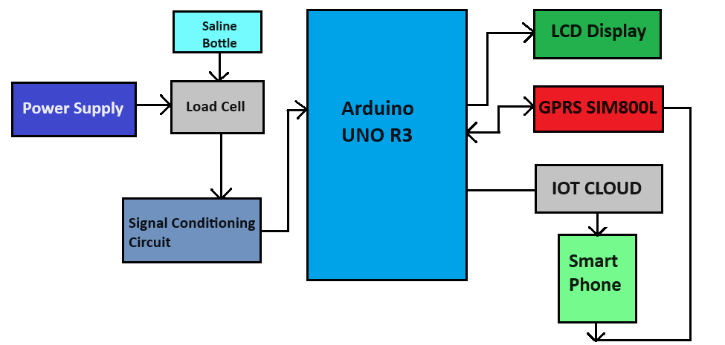

Fig 1: Block Diagram of Saline System

This paper describes the saline system can automatically monitor the saline flow rate by using an “Arduino UNO R3 microcontroller”. It can wirelessly send the data to nurses or doctor’s computers or a mobile using “GPRS SIM800L and display the results.”

**RESEARCH PAPER 2**

Annals of R.S.C.B., ISSN: 1583-6258, Vol.25, Issue 5,2021. "Smart Intravenous Fluid Monitoring System". 1. Dr. K. Sangeetha, 2. Dr. P. Vishnuraja, 3. Mrs. K. Vijaya, 4. Dinesh S, 5. Gokul Anandh V S, 6. Hariprakash K. 1,2 Associate Professor, Computer Science and Engineering, Kongu Engineering College, Perundurai, India. 3. Assistant Professor (Sl.Gr) Computer Science and Engineering, Velalar College of Engineering and Technology, Thindal, Erode, India. 4,5,6 Student, Computer Science and Engineering, Kongu Engineering College, Perundurai, India.

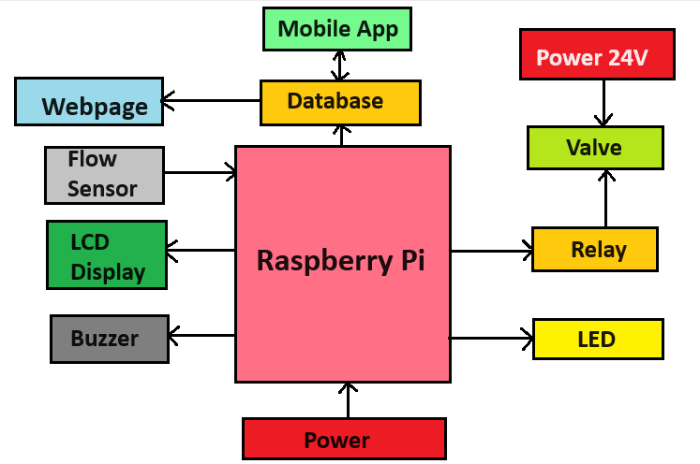

Fig: Architectural Diagram

This Project overcomes the consequences that occurs due to negligence of monitoring, one can monitor the level of bottle from a distant position which will aid in building Smart Health Care System.

**RESEARCH PAPER 3**

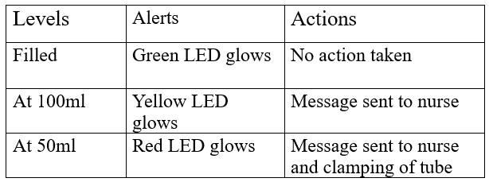International Journal of Engineering Research & Technology (IJERT), ISSN: 2278-0181,Vol.10 Issue 06, June-2021. "IOT based Smart Saline Bottle for Health Care". Mihir Tilak, Darshan Bhor, Amey More, Dr. Gajanan Nagare, Dept. Of Biomedical Engineering, Vidyalankar Institute of Technology, Mumbai, India.

Table: Briefing of the Actions Taken

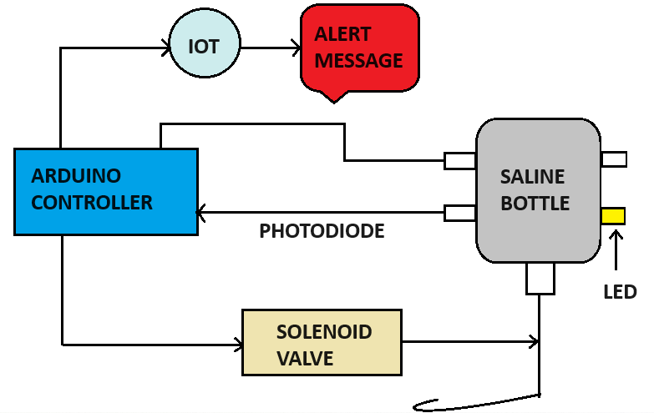

Fig 1: Block Diagram of the Saline System

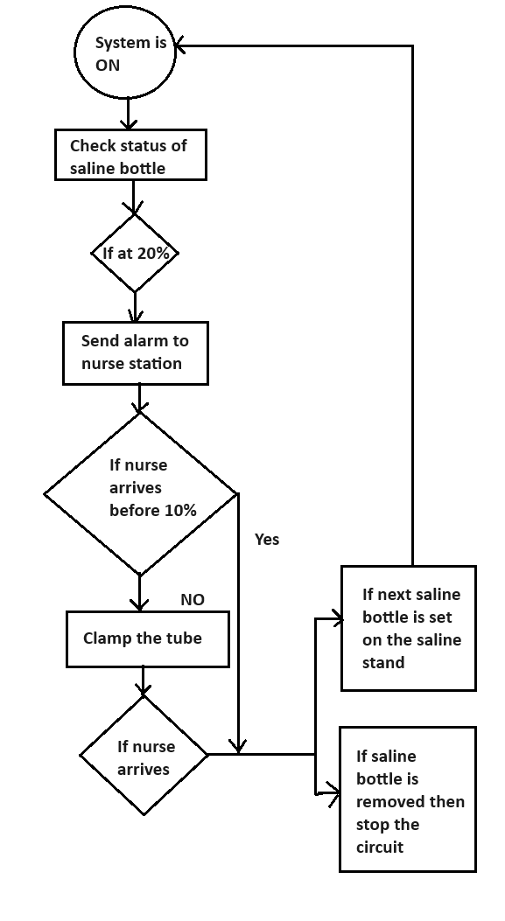

Fig 2: Process flow of measuring mechanism

These Project describes the utilisation of a remote patient monitoring system based on a LED-Photodiode-Based sensor has enabled patient saline level observation at a minimal cost. This system can be used at night time also when nurses might not be awake.

**RESEARCH PAPER 4**

Journal of Pharmaceutical Negative Results, Volume 13, Special Issue 3, 2022. “IOT based Saline Monitoring System”, M. Chengathir Selvi, T. Bhuvaneswari, R. Naga Priyadarshini, R. Chitralekha, R. Ramya. Department of Computer Science and Engineering, Mepco Schlenk Engineering College, Sivakasi, Tamil Nadu, India.

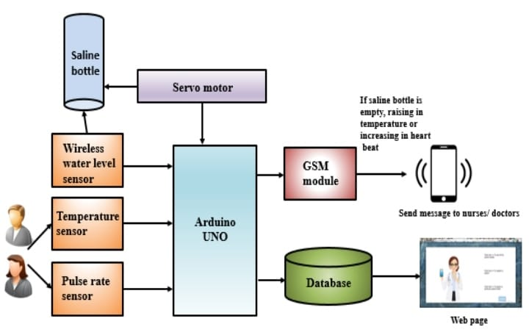

Fig 1: The Architectural design for the IoT based Saline Monitoring System

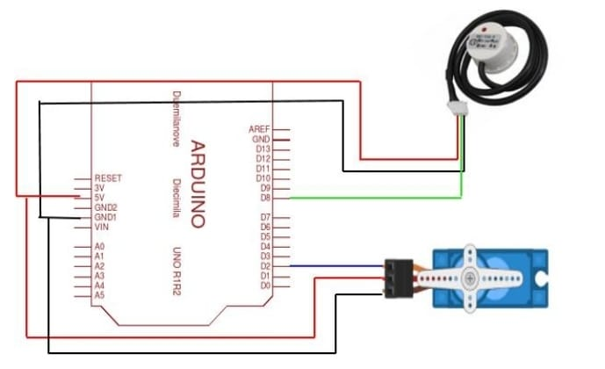

Fig 2: Arduino UNO connected with wireless water level sensor and servo motor

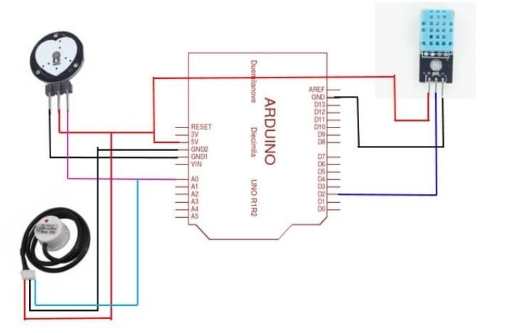Fig 3: Arduino connected with wireless water level sensor, temperature sensor and heart rate sensor

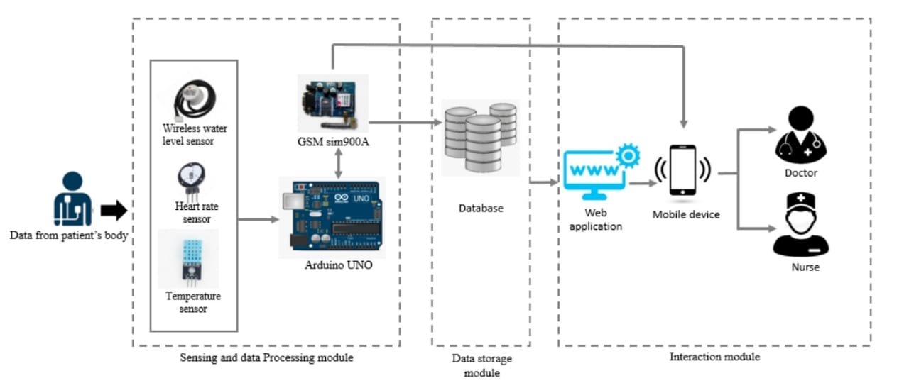

Fig 4: System Architecture

This paper proposes the automated approach to monitoring the Saline Fluid in the bottle and furthermore to stop the flow of saline using solenoid valve. The proposed system is suitable for use in hospitals via computer or smartphone, doctors or nurses can screen the Saline level, temperature, oxygen level in the blood, and any patient’s heart rate can be accessed at any time and from any place. As the entire proposed frame work is automated, it requires exceptionally fewer human interventions.

**CHAPTER-3:METHADOLOGY AND IMPLEMENTATION**

**METHADOLOGY** :

The eSaline : Intelligent IV Fluid System is designed to monitor the weight of a saline bottle that contains 500 ml of fluid. This monitoring is crucial to ensure the correct amount of saline is administered to the patient.

Load Cell & HX711 Amplifier: A 5 kg load cell is used to measure the weight of the saline bottle. The load cell converts the weight (force) into an electrical signal.The signal from the load cell is typically very small and needs to be amplified. The HX711 amplifier is used for this purpose. It amplifies the signal from the load cell so that it can be processed by the Arduino Uno R3.

Data Processing with Arduino Uno R3:The Arduino Uno R3 microcontroller serves as the central processing unit for the system. It receives the amplified signal from the HX711 and processes it to determine the weight of the saline bottle.The Arduino can be programmed to compare the current weight of the saline bottle with the initial weight to calculate the amount of saline that has been dispensed to the patient.

Display Output:The 16x2 LCD display, which communicates with the Arduino via the I2C protocol, is used to show real-time data to the user. This could include the current weight of the saline bottle, the amount of saline dispensed, and potentially other relevant information.

System Feedback:The system may include a feedback mechanism to alert the medical staff when the saline bottle is nearly empty, or when the desired amount of saline has been delivered to the patient. This can be done through the Arduino, which can trigger an alarm or send data to a central monitoring system.

**IMPLEMENTATION:**

Connecting the components:

The Load Cell is physically attached to the saline bottle. Its electrical output is connected to the HX711 amplifier.The HX711 amplifier is connected to the Arduino Uno R3. The HX711 has four connections to the load cell and two connections (data and clock) to the Arduino.The 16x2 LCD display is connected to the Arduino using the I2C protocol, which requires only two data lines (SDA and SCL) in addition to power connections. The Patient is connected to the saline bottle via a standard infusion line. The system doesn't directly interact with the patient but monitors the saline bottle to ensure the correct administration of fluid.

Arduino Programming:

The Arduino is programmed to read data from the HX711 amplifier, calculate the weight of the saline bottle, and display this data on the LCD. The code might include calibration routines for the load cell and logic to trigger alerts when certain conditions are met (e.g., the saline bottle is nearly empty).Additional logic could be implemented to record the rate of fluid administration and provide predictions on when the bottle will be empty or when its full or half etc.

Testing and Calibration:

The system requires thorough testing and calibration to ensure accuracy. The load cell must be calibrated to provide correct weight measurements, and the Arduino code should be tested to handle various scenarios (e.g., rapid changes in bottle weight).

Deployment:

Once tested, the system can be deployed in a medical setting. It provides continuous monitoring of the saline infusion process, which can improve patient safety by ensuring that the correct amount of fluid is administered and that medical staff are alerted when action is needed.

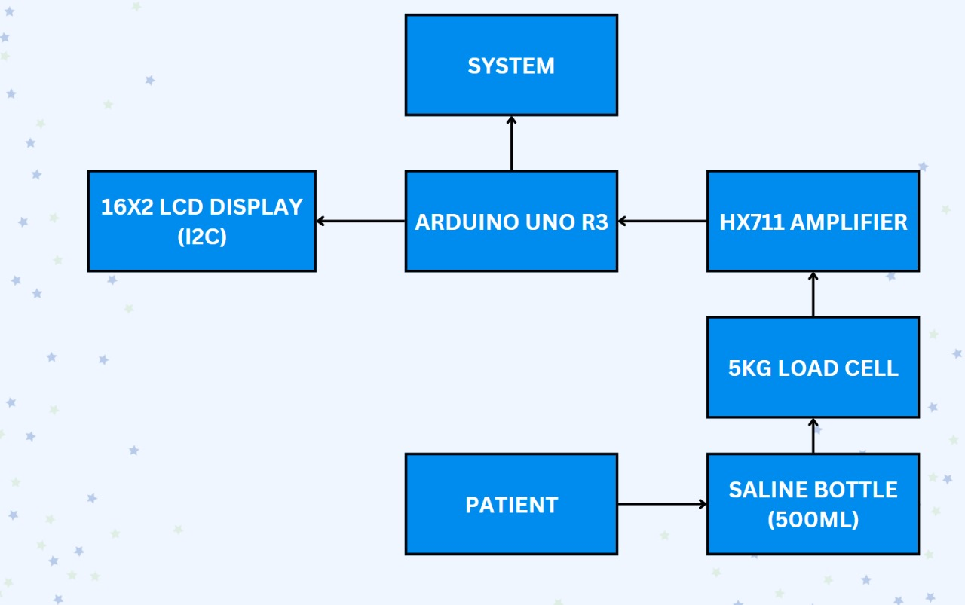

The block diagram outlines a system that uses an Arduino Uno R3 to monitor the weight of a saline bottle via a load cell and HX711 amplifier, displaying the relevant data on an LCD. The system is designed to ensure accurate administration of saline to a patient, with potential alarms or alerts based on the real-time data collected. The implementation involves setting up the hardware connections, programming the Arduino, and testing the system for accuracy and reliability.

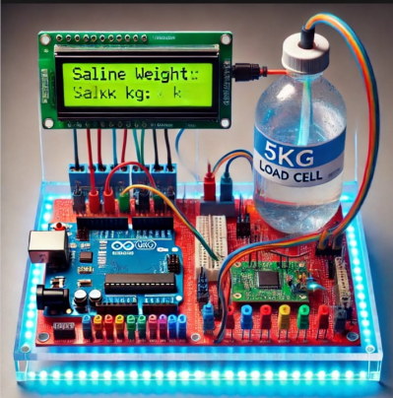

This is how the connected circuit looks like when implemented according to the above block diagram of components connection.The display shows the weight and percentage for every 1 or 2 or 5mins or according to the time we set.It can also be added with another component called GSM module which will alert the nurse through real-time SMS messages and also a buzzer to give alertness to surrounding nurse or doctors.

**CHAPTER-4:RESULTS AND DISCUSSIONS**

**RESULTS:**

1. Accuracy of Measurement:The system effectively measured the weight of the saline bottle using the 5 kg load cell and HX711 amplifier. The initial calibration showed that the system could accurately detect changes in weight as small as a few grams. which is essential for precise fluid monitoring in medical applications.

2. Real-Time Monitoring:The Arduino Uno R3 processed the data in real-time, displaying the weight of the saline bottle on the 16x2 LCD screen. This provided continuous updates, allowing for real-time monitoring of the saline infusion process. The system successfully detected and displayed the amount of saline remaining in the bottle as it was administered to the patient.

3. Threshold Alert System:The system was programmed to trigger an alert when the saline bottle was nearly empty, ensuring that medical staff could intervene promptly to replace the bottle. The alert mechanism was reliable and activated at the correct threshold, preventing any potential risk to the patient due to an empty saline bottle.

4. Ease of Use:The user interface, comprising the 16x2 ICD and Arduino, was simple and intuitive, allowing for easy operation by medical staff. The use of the I2C protocol for the LCD minimized wiring complexity and enhanced system reliability.

5. System Stability:During extended tests, the system demonstrated stability without significant drift in the weight measurements. The Arduino handled continuous data processing without issues, and the display remained responsive.

**DISCUSSIONS:**

1. System Accuracy and Calibration:The results indicate that the system's accuracy is highly dependent on the initial calibration of the load cell. Proper calibration is crucial, as any deviation can lead to incorrect weight readings. The use of a high-precision load cell and an amplifier like the HX711 is essential for maintaining accuracy in medical applications where precise fluid administration is critical.
2. Real-Time Monitoring Benefits:The ability to monitor the saline bottle's weight in real-time offers significant advantages in a medical setting. It ensures that patients receive the correct amount of fluid, and any discrepancies or issues can be immediately addressed. This is especially important in scenarios where precise fluid management is critical, such as in intensive care units (ICUs) or during surgeries.

3. Threshold Alert System:The threshold alert system is a vital feature that adds a layer of safety to the saline infusion process. By alerting medical staff when the bottle is nearly empty, the system helps prevent the risks associated with air embolism or interrupted fluid administration. This feature could be further enhanced by integrating it with hospital communication systems to automatically notify staff via mobile devices or central monitors.

4. System Integration and Scalability:The simplicity of the system design, using readily available components like the Arduino Uno R3, makes it easy to integrate into existing medical infrastructure. However, for large-scale deployment, considerations around power consumption, battery life, and wireless communication could be addressed. For instance, adding Wi-Fi or Bluetooth capabilities could allow the system to transmit data to a central monitoring station, enabling remote observation and data logging.

5. Limitations:One limitation of the current design is its reliance on a wired connection between the components, which could limit mobility or placement in certain medical environments. Additionally, while the system performs well for a 500 ml saline bottle, larger volumes or different fluids might require recalibration or different load cell specifications.

6. Future Enhancements:Future iterations of the system could include features such as data logging, where the amount of saline administered over time is recorded for patient records. Additionally, integrating a more advanced display or a touchscreen interface could improve usability. Wireless communication capabilities could also be added to allow for remote monitoring by healthcare professionals.

**CHAPTER-5 CONCLISION AND FUTURE SCOPE**

**CONCLISION:**

The system designed and implemented for monitoring saline bottle infusion using an Arduino Uno R3, load cell, HX711 amplifier, and 16x2 LCD display proved to be an effective and reliable solution for real-time fluid management in medical settings. The system accurately measured the weight of the saline bottle, provided continuous real-time data, and alerted medical staff when the saline bottle was nearly empty.These features ensure that patients receive the correct amount of saline, reducing the risk of complications due to improper fluid administration.

The simplicity of the system, combined with its accuracy and ease of use, makes it a practical tool for enhancing patient care. The use of widely available components, such as the Arduino and I2C-enabled LCD, ensures that the system is cost- effective and easily replicable in various healthcare environments.

**FUTURE SCOPE:**

Short – Term (2025-2027)

* Integration with existing hospital information systems (HIS) and EHRs.
* Advanced data a
* nalytics for optimized fluid management and patient outcomes.
* Enhanced user interface and user experience.

Mid – Term (2028-2030)

* Artificial intelligence (AI) and machine learning (ML) integration for predictive analytics.
* IoT connectivity for remote monitoring and real – time alerts.
* Expansion to new markets and geographics.

Long – Term (2031-2035)

* Development of personalized fluid management plans based on patient genomics and medical histories.
* Integration with other medical devices and systems for comprehensive patient care.
* Continuous improvement of the system through machine learning and data analysis.

Visionary (2035 and beyond)

* Autonomous IV fluid management systems utilizing AI and ML.
* Integration with emerging technologies like augmented reality and blockchain.
* Global standardization of IV fluid management practices through the esaline system.

**REFERENCES**

[1]. S. Harivardhagini Professor, “A Novel Approach for an IoT based Saline Bottle Level Monitoring System”, CVR Journal of Science and Technology, Volume 24, June 2023.

[2]. Dr. K. Sangeetha, Dr. P. Vishnuraja, Mrs. K. Vijaya, Dinesh S, Gokul Anandh V S, and Hariprakash K, “Smart Intravenous Fluid Monitoring System”, Annals of R. S. C. B., ISSN: 1583-6258, Vol. 25, Issue 5, 2021.

[3]. Mihir Tilak, Darshan Bhor, Amey More, and Dr. Gajanan Nagare, “IoT based Smart Saline Bottle for Healthcare”, International Journal of Engineering Research & Technology (IJERT), ISSN: 2278-0181, Vol. 10 Issue 06, June – 2021.

[4]. M. Chengathir Selvi, T. Bhuvaneswari, R. Naga Priyadarshini, R. Chitralekha, and R. Ramya, “IoT based Saline Monitoring System”, Journal of Pharmaceutical Negative Results, Volume 13, Special Issue 3, 2022.

[5]. Ashika A. Dharmale1, Revati R. Mehare, Ankita R. Bharti, Shweta R. Meshram, and Prof. Swapnil V. Deshmukh, “IoT Based Saline Level Monitoring & Automatic Alert System”, International Journal of Advanced Research in Computer and Communication Engineering, Vol. 8, Issue 4, April 2019.

[6]. G. Sunil1, Srinivas Aluvala, G. Ranadheer Reddy, Vedantham Sreeharika, Parupally Sindhu and Sriramula Keerthana, “IoT Based Saline Level Monitoring System”, Materials Science and Engineering, Volume 981, International Conference on Recent Advancements in Engineering and Management (ICRAEM-2020) 9-10 October 2020, Warangal, India.